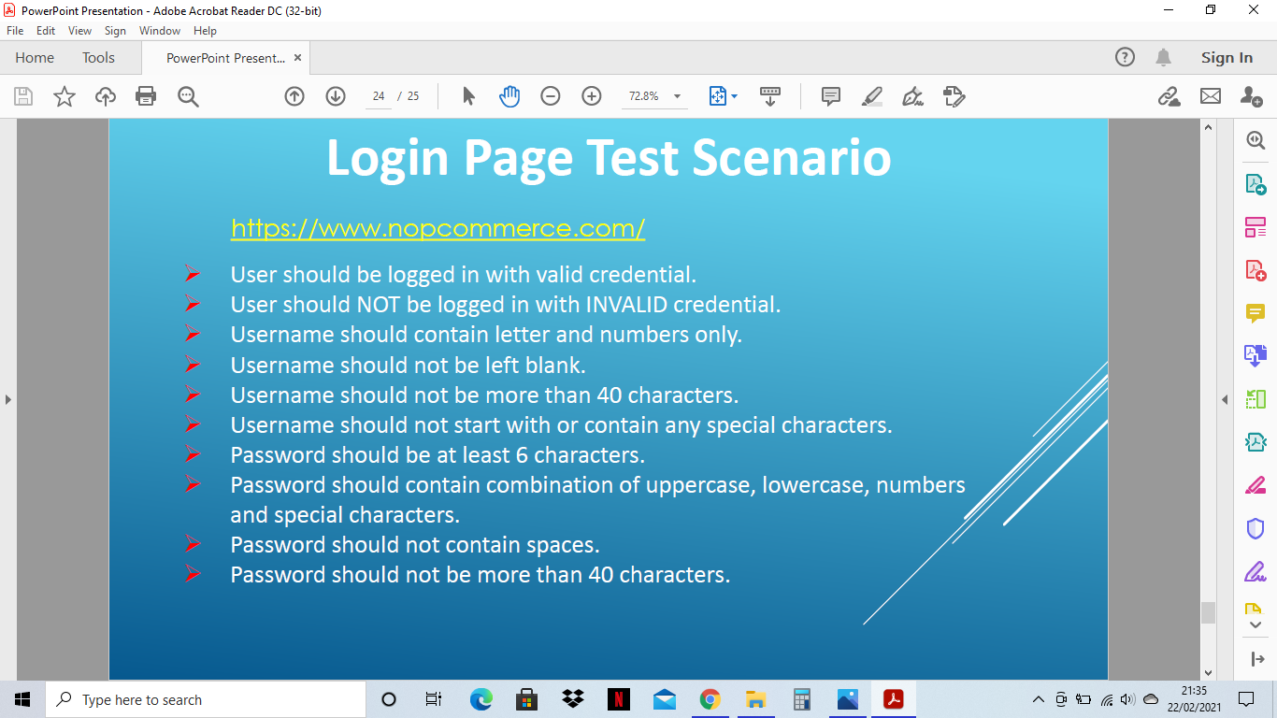

* First I visit the website
* At bottom of the page I click the register button.
* Which took to register the form
* Fill up the form according to instruction
* After registration complete, a message pop up for confirming e-mail
* Into the mail I have click the link for confirmation
* After clicking the link Account was activated
* Recheck by log in and log out it successfully show I can log in and log out.

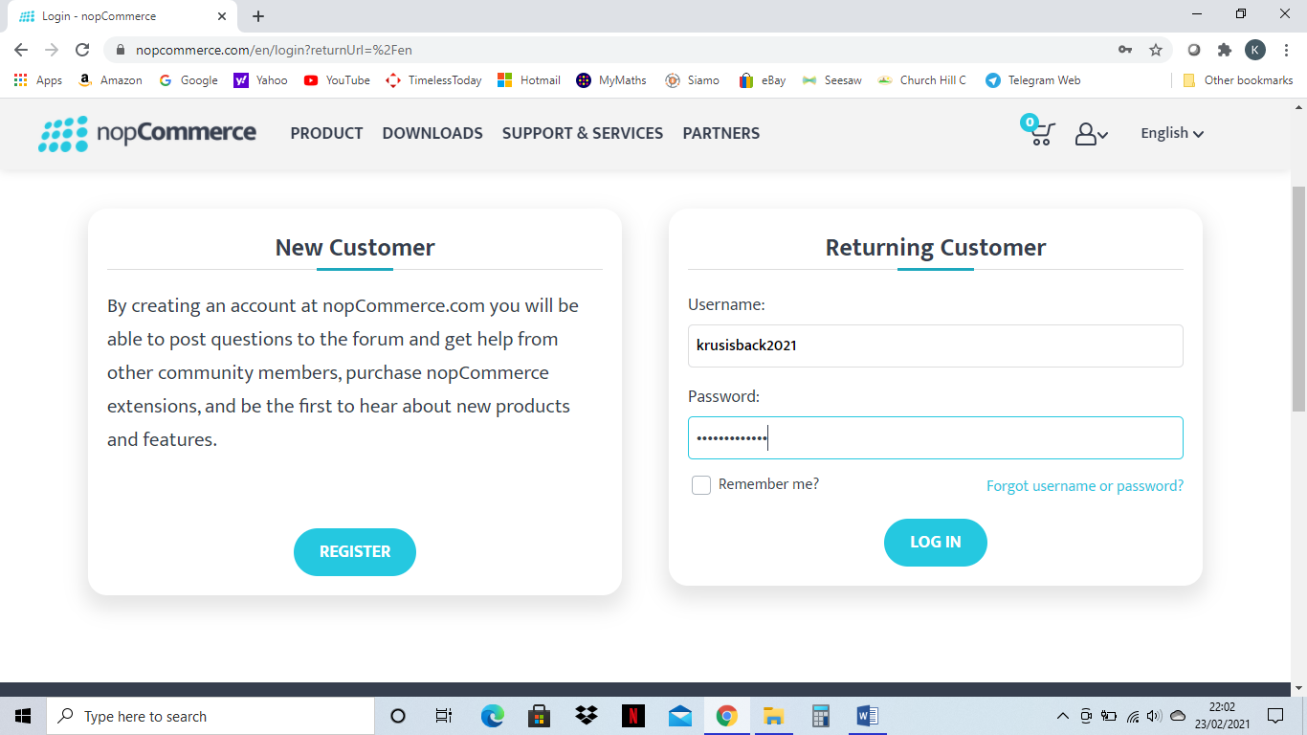

1. User have logged in with valid credential.
2. User have not logged in with INVALID credential.
3. Username have contained letter and numbers only.
4. Username is not left blank.
5. Username have 14 characters (krusisbak2021) which not more than 40 characters.
6. Username is not start with any special character as it starts with small letter “k”.
7. Password is Software@2021 which is 13 characters according to requirement.
8. Password contain Upper case, Lower case, numbers and special characters.
9. Password has no spaces.
10. Password is not containing more than 40 characters.

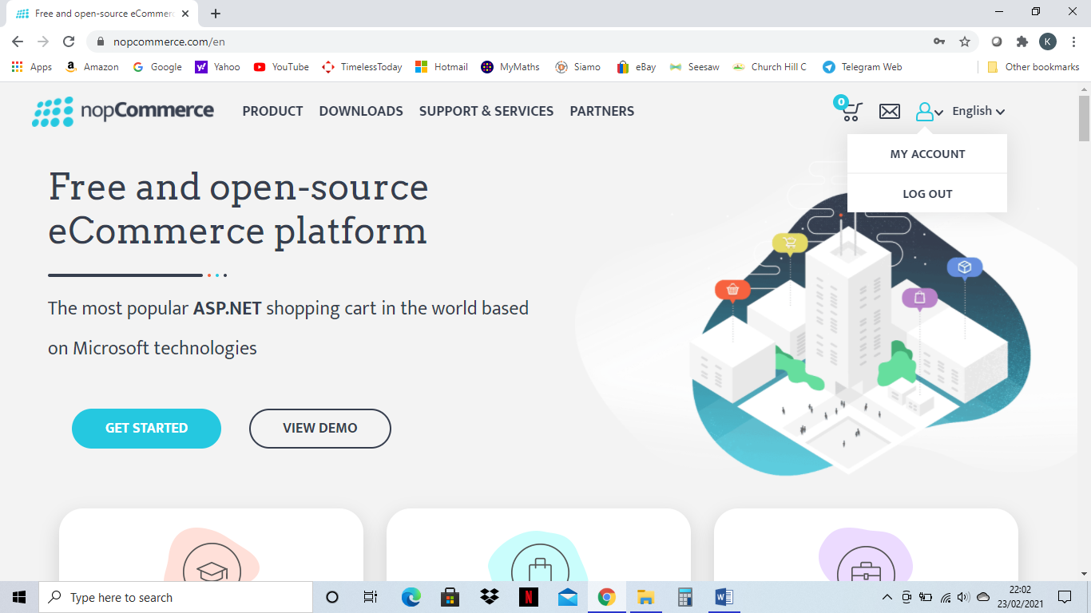

**Successfully log into the account.**

**7 Principles of Software Testing**

1. **Exhaustive testing is not possible**

It explains by repeating same thing can get boring and exhaust to do it again and again. For example, log in Gmail account or Amazon account 1000 time is boring and exhaust.

1. **Defect Clustering**

It explains a small number of features causes majority of quality issues in an application. For example, a bug can be found in first page of BBC website and there is more possible similar bug can be found in website link pages.

1. **Pesticide Paradox**

For example, if we find bug on one page and always concentrate on same page to look out for bug that means we not focusing on other pages to find the bug. And this way we can never find bugs on other pages of website.

1. **Testing shows presence of defects / bugs**

It means every time when doing the testing we find defects and it cannot become 100% bug free. In other word when checking everything and clearing the bug, when it comes to re check there can be presence of bug.

1. **Absence of errors fallacy**

It explains that doesn’t matter how many time we do test but still will have defects and it is of no use to tester and client.

1. **Early Testing**

Doing early testing help to find any problem which can occurs and will help to save time and cost.

1. **Testing is context dependent**

It dependent on individual how they work for example if you using Amazon website is different than NHS website as it can be critical.

The methods and types of **testing** carried out can completely depend on the **context** of the software or systems